Task 1: [2 marks]
- Use the following code snippet to download Peter Norvig’s unigram corpus, and load it into a dataframe, unigrams_df
import pandas as pd
#install and import the jellyfish library
!pip install jellyfish
import jellyfish

!wget https://norvig.com/ngrams/count_1w.txt #unigram corpus
filePath1 = "/content/count_1w.txt"
unigrams_df = pd.read_csv(filePath1,sep='\t',header=None, names=['unigram','count']) #keep_default_na to be set here to avoid NaNs
print(f'Number of unigrams: {unigrams_df.shape[0]}')
display(unigrams_df.head(100))

- Write a simple spelling correction function that takes a non-word string as input (i.e. non-word misspellings such as “acress”), and prints out a list of candidate corrections.
- Hint 1: only use the language model/priors, i.e. the unigram counts stored in unigrams_df, and ignore the channel/error model probabilities.
- Hint 2: Use the Damerau-Levenshtein Distance function in the jellyfish library for candidate generation.
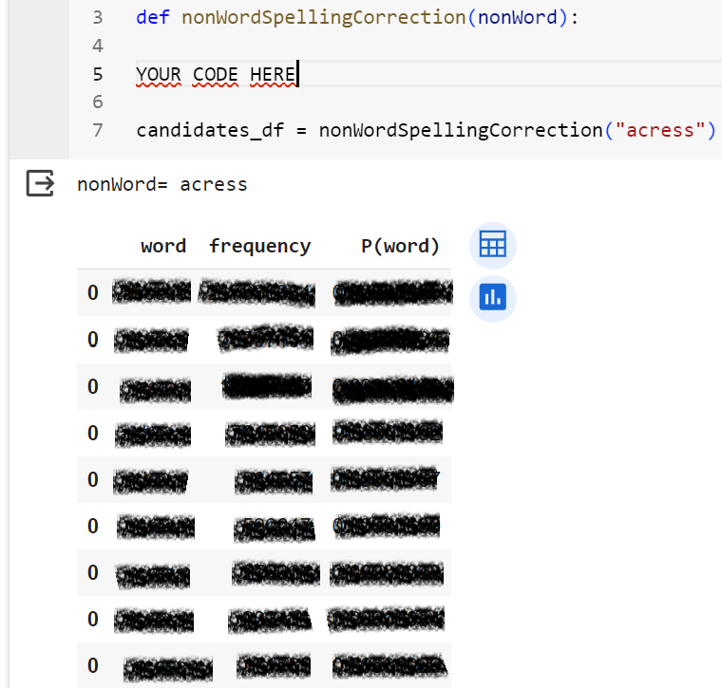

Task 2. [1.0 mark]

(a) Use the TextBlob Library (https://textblob.readthedocs.io/en/dev/) to write a function that takes a string (e.g. acress) as input and returns a list of (word, confidence) tuples with spelling suggestions.
Sample output:

(b) Use the TextBlob Library (https://textblob.readthedocs.io/en/dev/) to write a function that takes a sentence as input and corrects its spelling.
Sample output:
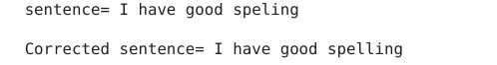

</END OF ETIVITY>

Teaching Team:
- Level of difficulty (easy/fair/hard)
- http://norvig.com/spell-correct.html
- Implementing Damerau-Levenshtein Distance instead of using a library.
- Can POS and NER material & tasks be added here (workload balance?) Introduction to Part of Speech Tagging

